Operation and Maintenance Manual
John Q. Family Single Family Home

Prepared For
SDEV21-001Z
Project Location
6816 S. Alder
4940000270

Prepared By
Name | Organization | Contact Telephone Number | Email Address
Alice B. Contractor | ABC Contracting | 123456789 | abc@abc.com

Person(s) Responsible for Maintenance of Stormwater Facilities
Name | Organization | Contact Telephone Number | Email Address
Alder Pine | None | 123456897 | alderp@ash.com

Date Prepared
06/03/2021

Operation and Maintenance Manual will be kept at: the home. The O&M Manual must be made available for inspection by the City upon request.

Facility Summary

Narrative Description of proposed stormwater system: (Insert Short Description of System)
Facility Location Identifier on associated figure. | Facility Type – Provide BMP Name and Number from SWMM. Include Manufacturer Name and Manufacturer Model Number, if applicable. | Facility Description – What Facility Does, How it Works, and applicable information such Number of Cartridges, Type of Cartridges, Height of Cartridges, etc. as applicable for Emerging Technologies | Estimated Operation and Maintenance Cost
1 and 2 | BMP L601: Rain Garden | Stormwater enters the rain garden from the roofs via pipes and slowly infiltrates into the underlying soil. | $200/Year
3, 4, and 5 | BMP T1050: Compost Amended Vegetated Filter Strip | Stormwater sheet flows off the adjacent walkways and sidewalks where is disperses and infiltrates into the adjacent soil. | $30/Year
6 | Stormwater Pipes and Cleanouts | Pipes collect and convey stormwater from roof surfaces to the rain gardens. | $10/Year
7 | BMP L603: Soil Quality and Depth | Amended soils and overlying vegetation help ensure rain stays onsite and does not create stormwater runoff. | $20/Year

Site Plan Showing Facility Locations
Insert Figure below showing location of the permanent stormwater system with facilities clearly labeled.

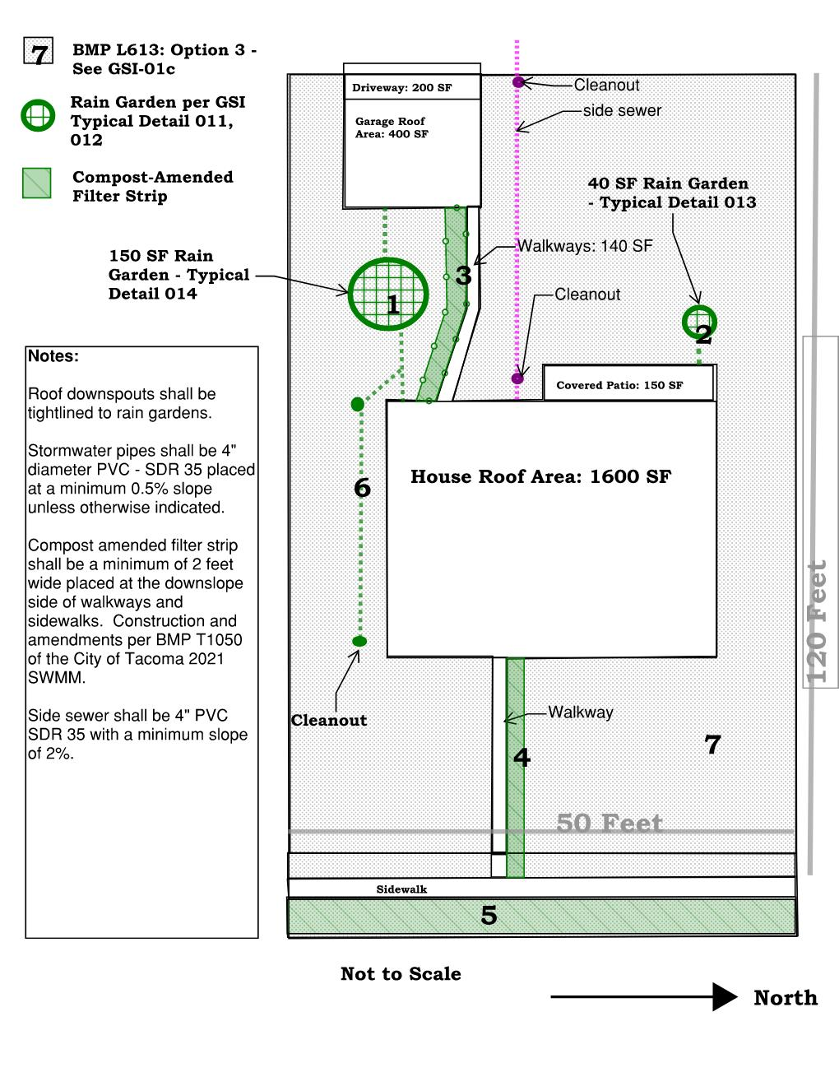

Maintenance Schedules
Attach a description of all maintenance tasks and the frequency of each task for each facility. Include any manufacturer’s recommendations. The appropriate Maintenance Standards from Volume 4, Appendix C of the SWMM can be used for this purpose where they are available for a given BMP.

Maintenance Activity Log
Provide a sample maintenance activity log indicating emergency and routine actions to be taken. Attach to this document.

Covenant and Easement Agreement
Include a copy of the recorded Covenant and Easement Agreement. Include a copy of recorded document if available.

Access and Easement Documentation
Include all associated access and easement documents that may be associated with the permanent stormwater system. Include copy of recorded document if available.

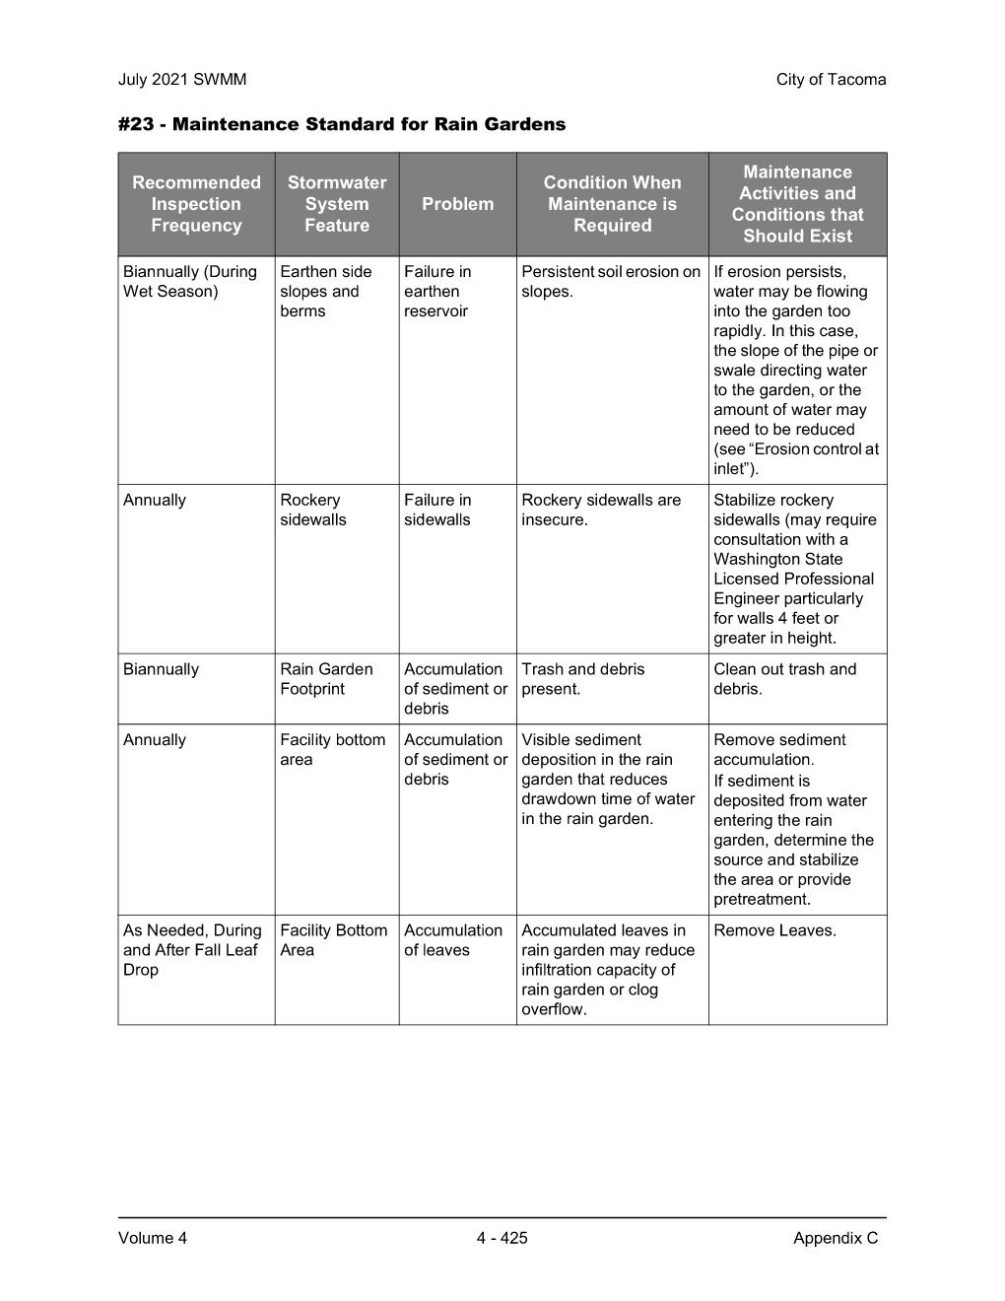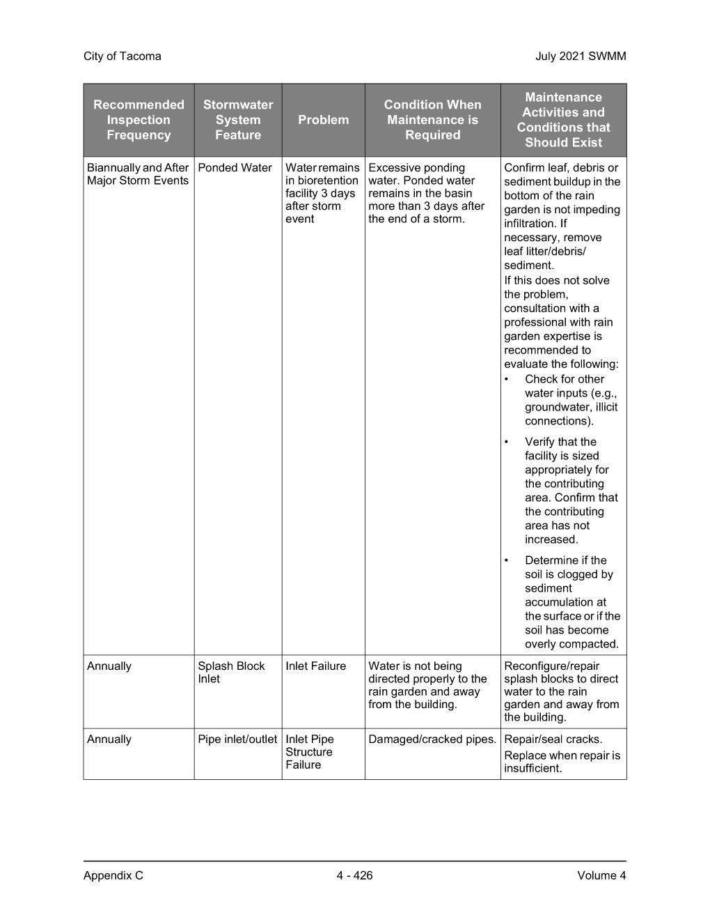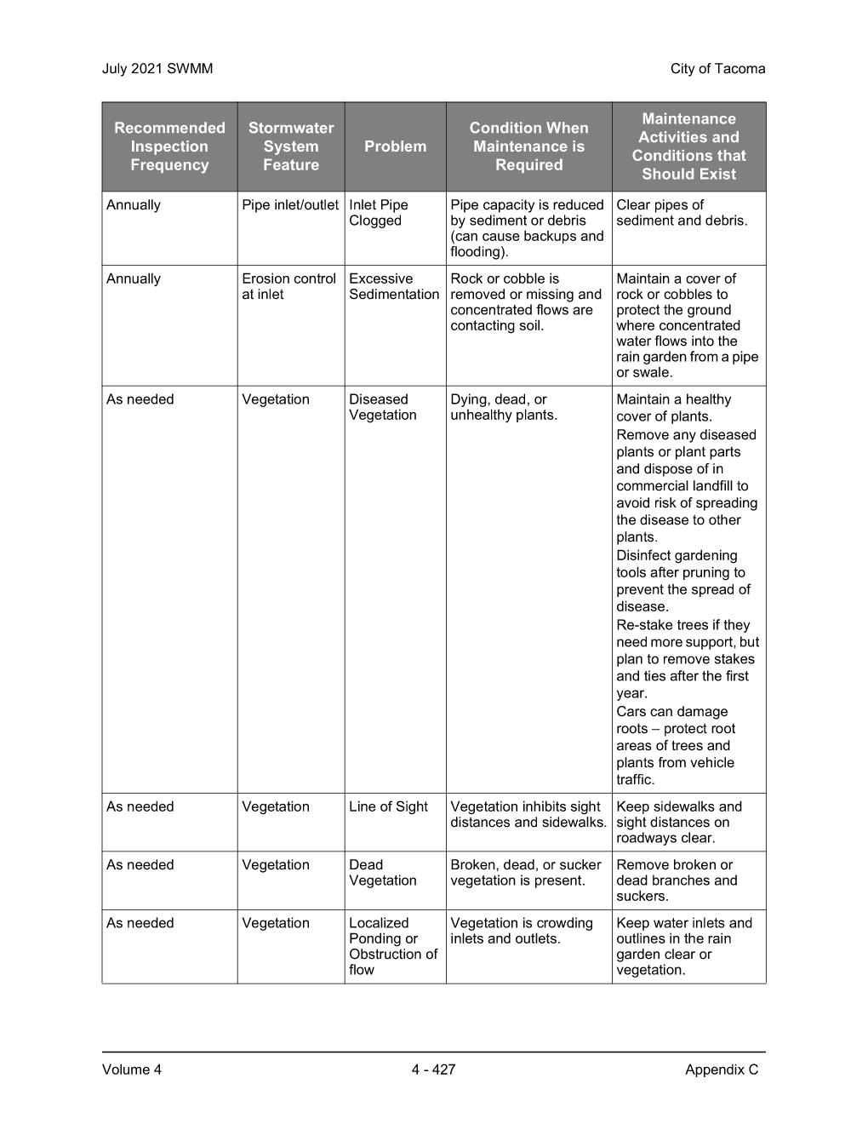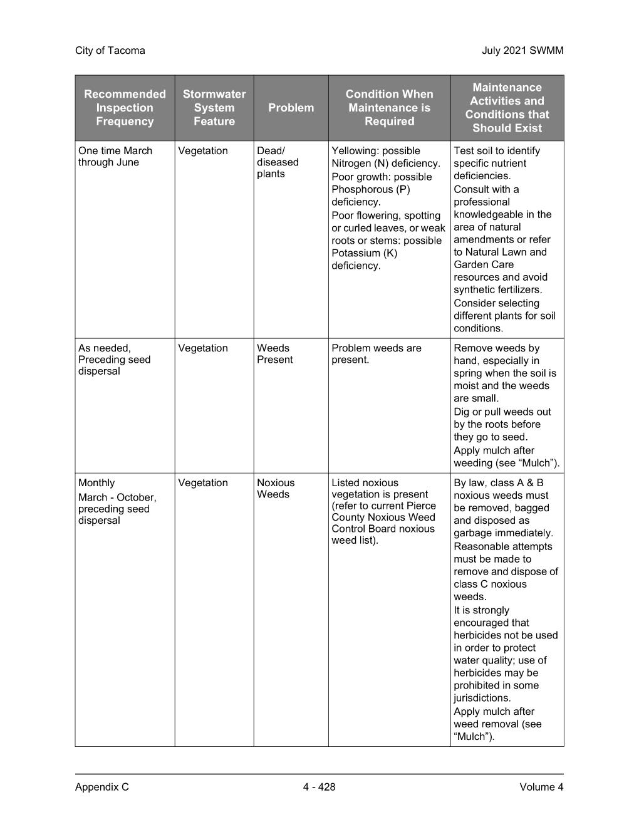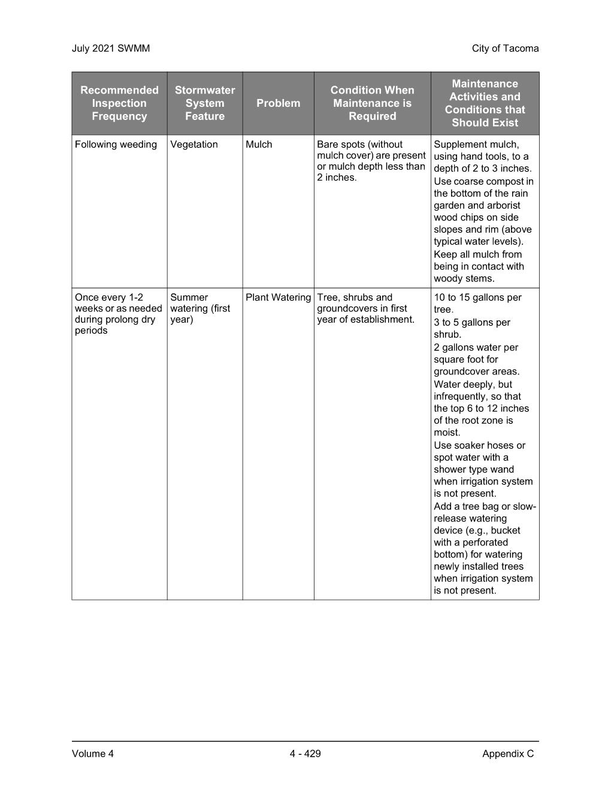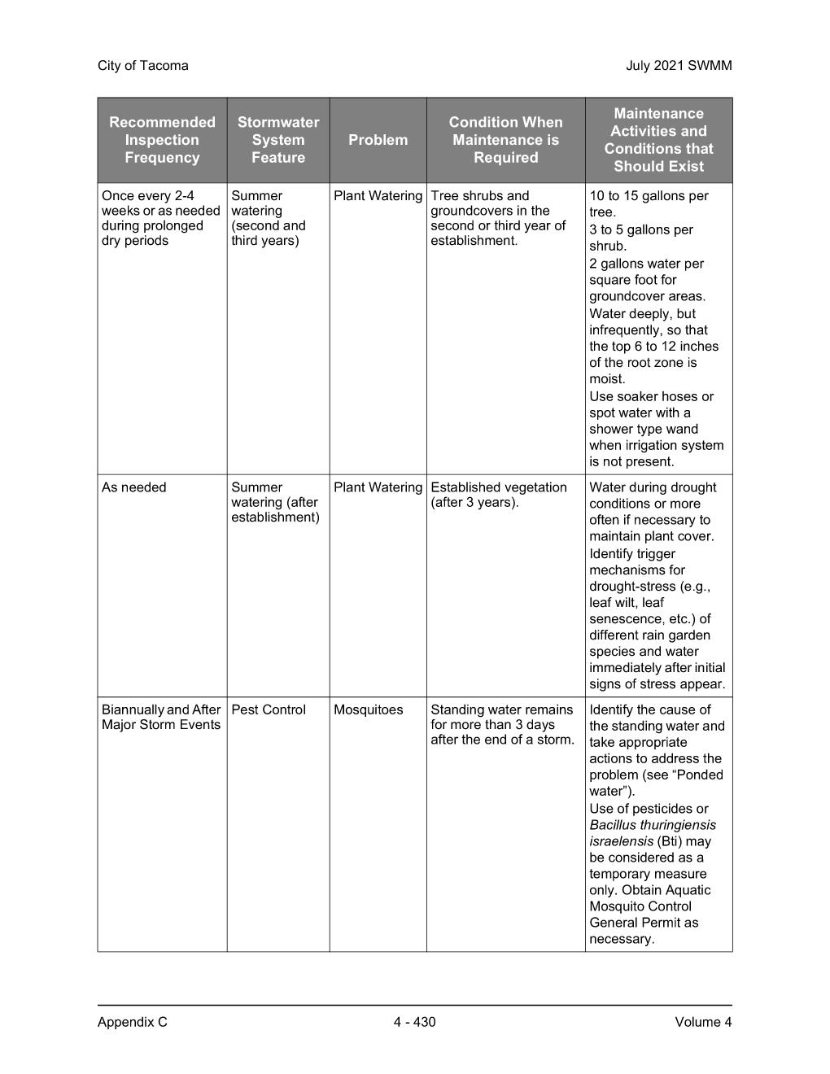

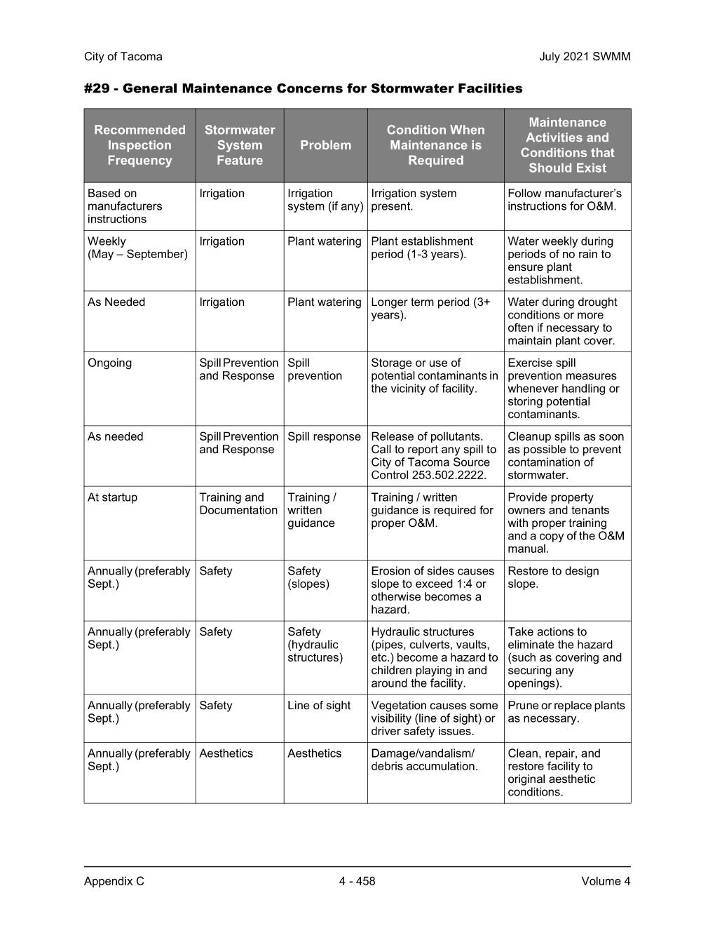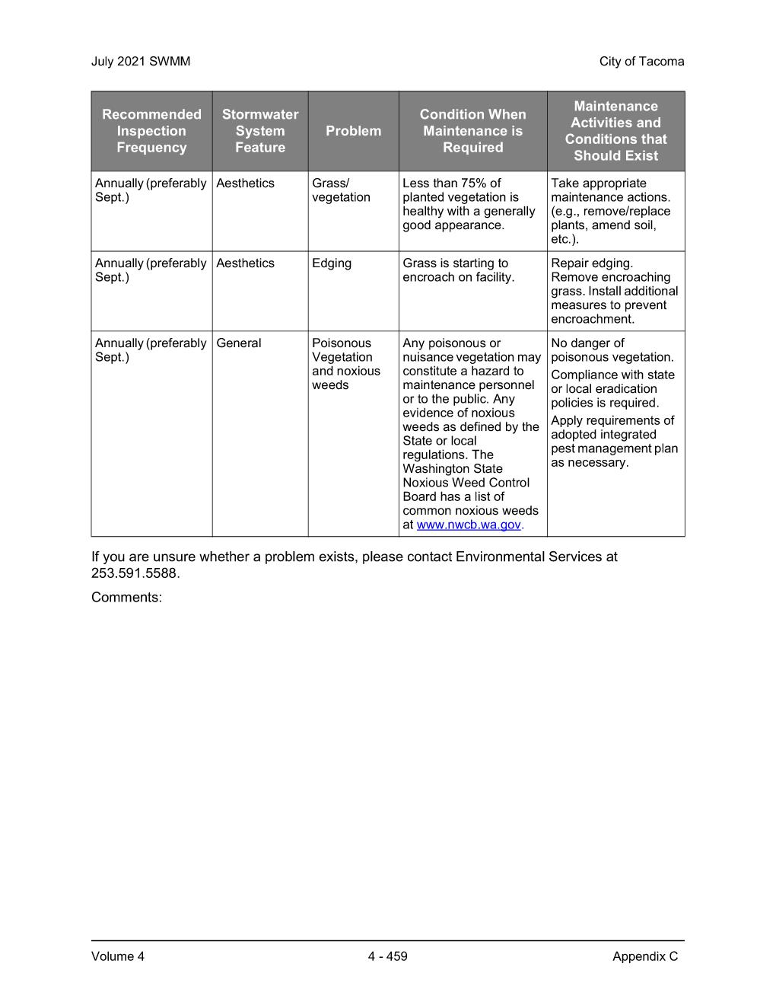

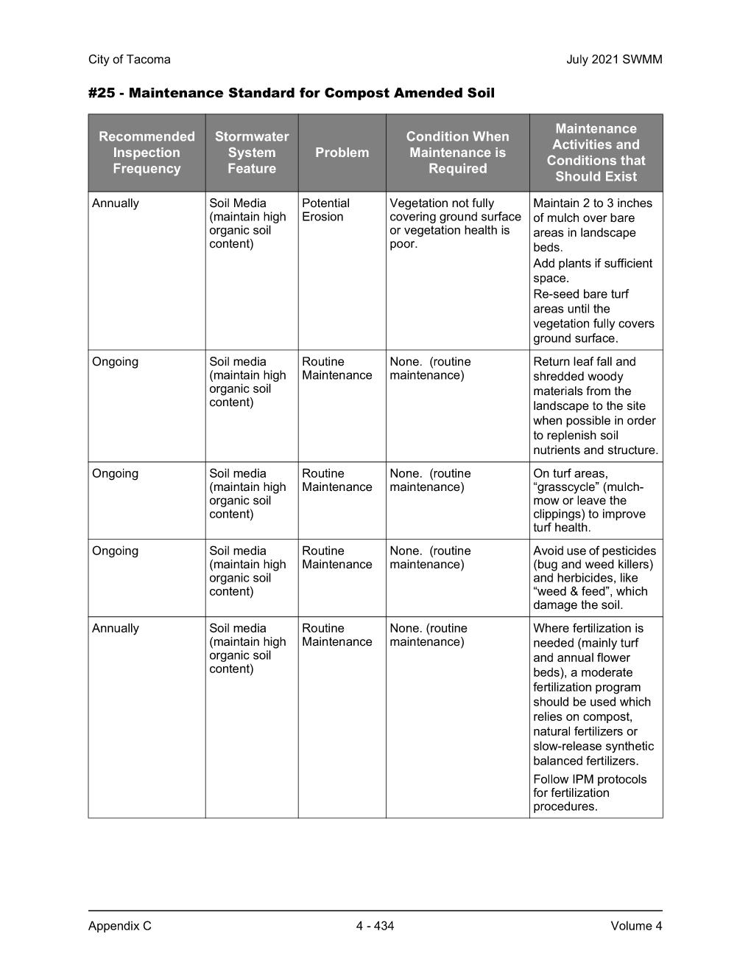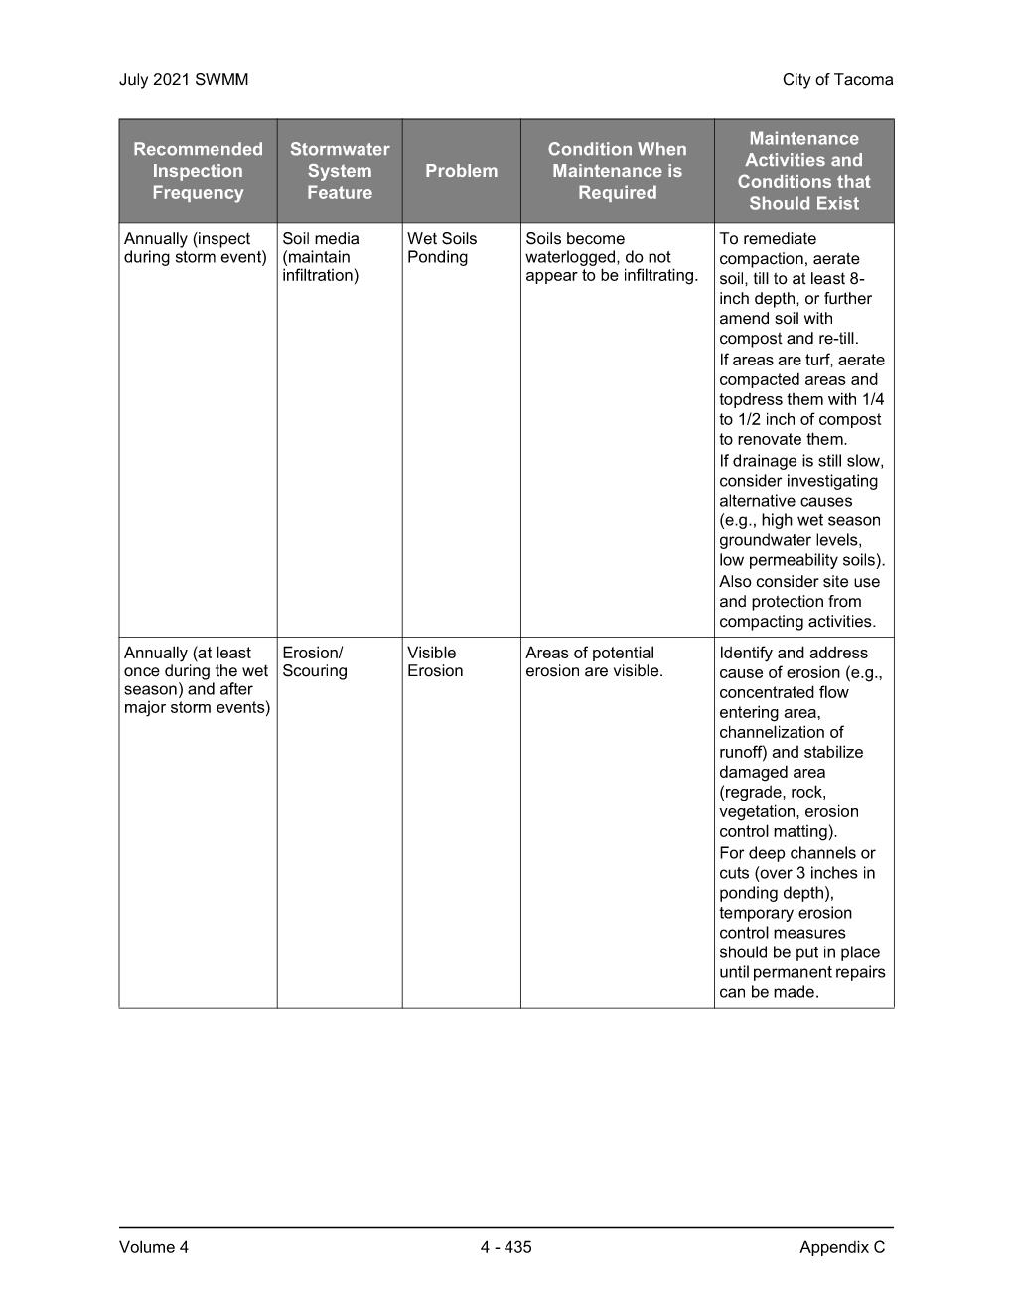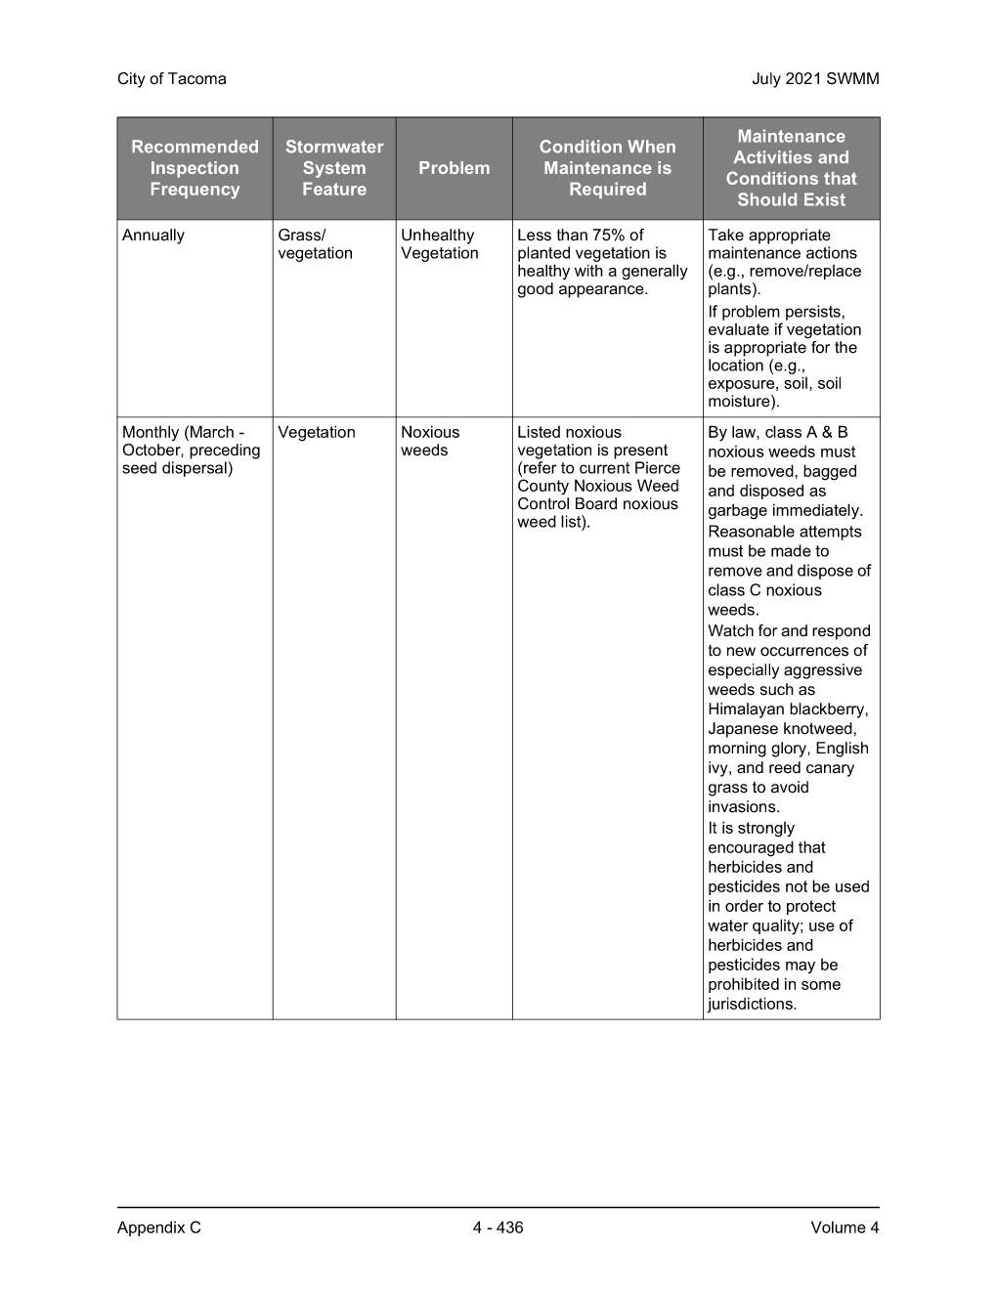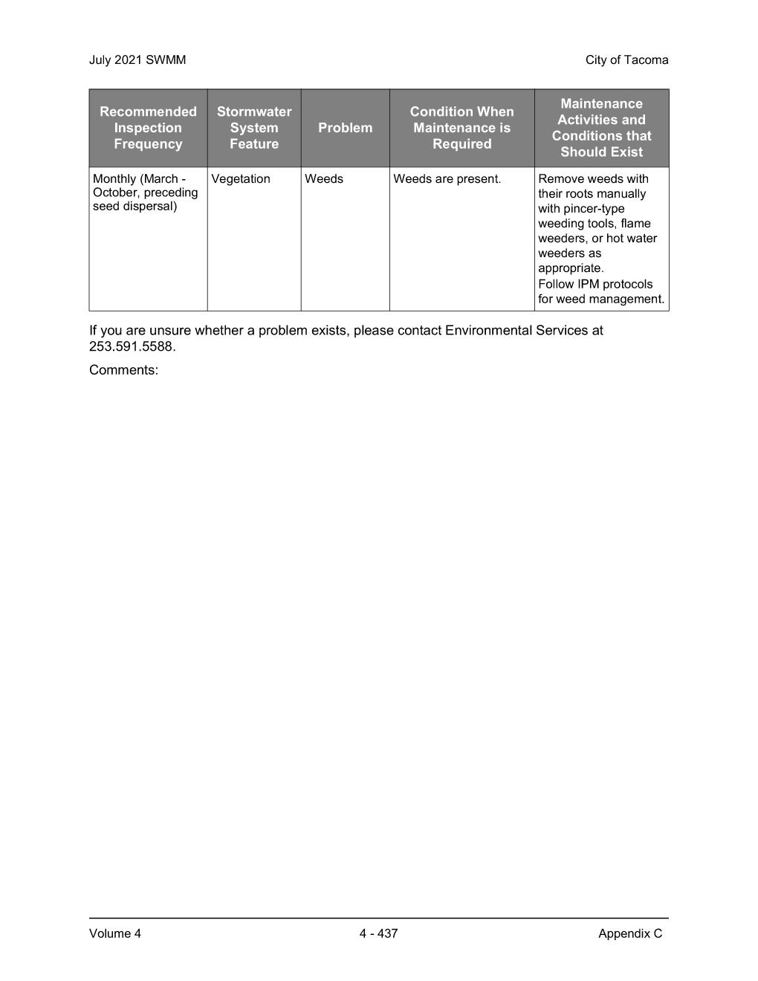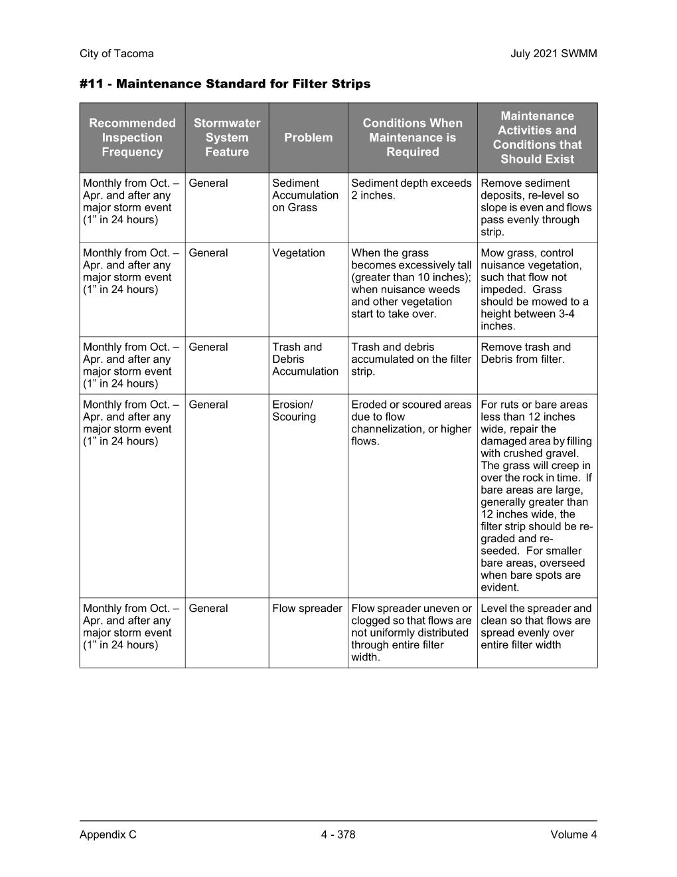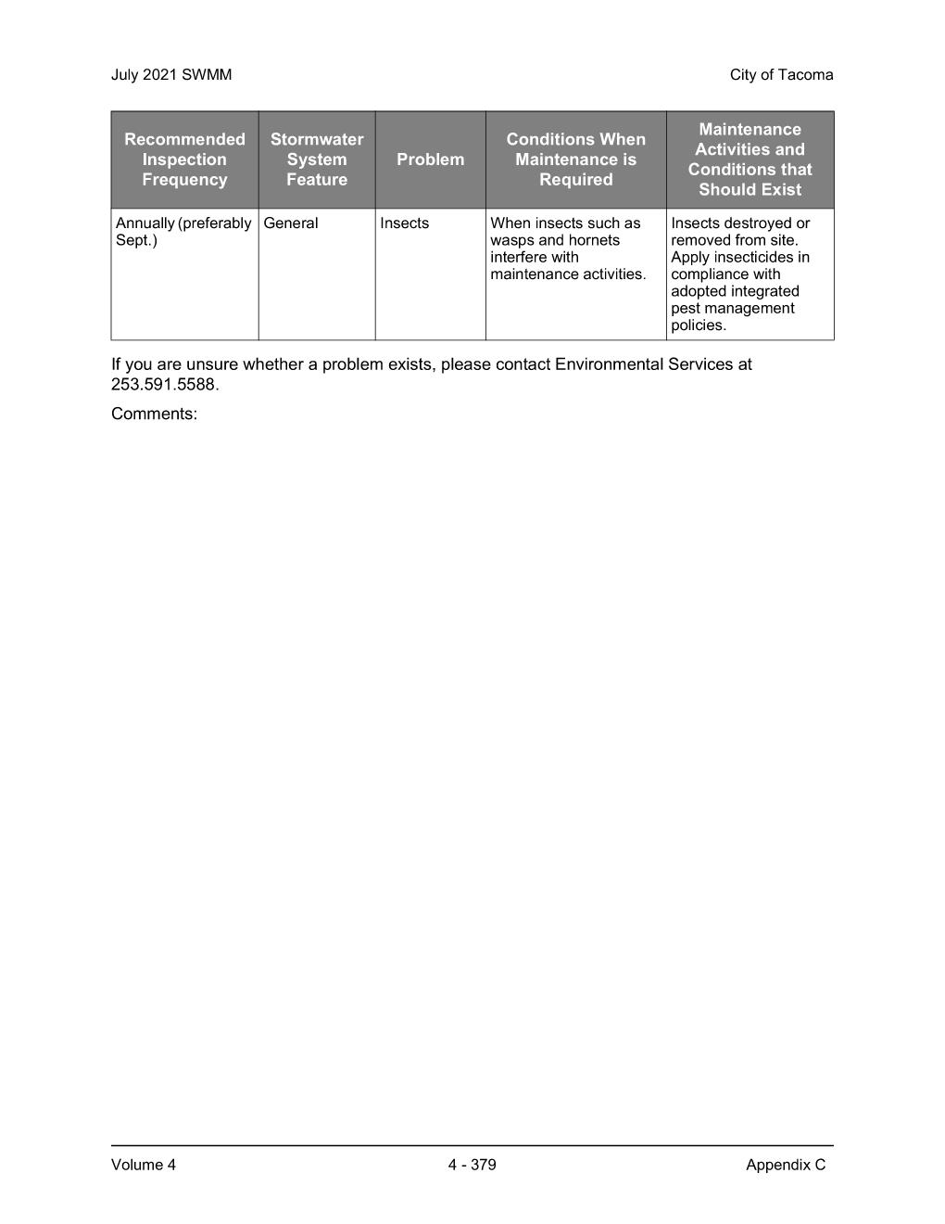
Maintenance – Stormwater Pipes
At least yearly check to ensure stormwater pipes are still connected to the downspout system and are discharging into the rain gardens. Open cleanouts to check pipe condition and ensure no excess sediment or debris is in pipe system. Clean gutters yearly to keep stormwater flowing.

Sample Inspection Checklist and Activity Log

Inspection Date: Action Required: ☐Yes ☐No
Inspector Name:

During inspection do not compact rain garden soil area. Walk lightly and do not use heavy equipment within the facility.

Photos
- Were photos taken today of all components of the stormwater system? ☐Yes ☐No
- Take photos with every inspection.

Rain Garden Area Maintenance
- Is trash present? ☐Yes ☐No
- Remove trash and leaves from bioretention area. Replant as necessary.
- Action Taken: ☐ Maintenance Completed ☐Maintenance Requested
- Comments: _______________________________________________________________
- Are noxious weeds present? ☐Yes ☐No
- Noxious weeds shall be removed as soon as feasible. See noxious weed handout. Dispose of noxious weeds properly.
- Action Taken: ☐ Maintenance Completed ☐Maintenance Requested
- Comments: _______________________________________________________________
- Is there evidence of oil, gasoline, or other contaminants? ☐Yes ☐No
- Remove all contaminants as soon as feasible.
- Action Taken: ☐ Maintenance Completed ☐Maintenance Requested
- Comments: _______________________________________________________________
- Is insect control needed? ☐Yes ☐No
- Remove insects if they interfere with maintenance.
- Action Taken: ☐ Maintenance Completed ☐Maintenance Requested
- Comments: _______________________________________________________________
- Is there standing water in the facility 48 hours or longer after rain event? ☐Yes ☐No
- Remove sediment or trash.
- If standing water still exists after sediment, trash, debris removal – removal and replacement of rain garden soil mix may be required.
- Action Taken: ☐ Maintenance Completed ☐Maintenance Requested
- Comments: _______________________________________________________________
- Are there signs of erosion on the side slopes or near inlets?☐Yes ☐No
- Repair erosion damage over 2 inches deep. Stabilize with plantings.
- If erosion is persistent (noted at each inspection): Call 253.502.2105.
- Action Taken: ☐ Maintenance Completed ☐Maintenance Requested
- Comments: _______________________________________________________________
- Are rodent holes present? ☐Yes ☐No
- Remove rodents and repair holes.
- Action Taken: ☐ Maintenance Completed ☐Maintenance Requested
- Comments: _______________________________________________________________
- Is inlet pipe clogged or damaged? ☐Yes ☐No
- Remove debris or vegetation clogging inlet pipe.
- Repair inlet pipe.
- Action Taken: ☐ Maintenance Completed ☐Maintenance Requested
- Comments: _______________________________________________________________
- Is rock protection present around inlet pipe? ☐Yes ☐No
- Repair or replace rock protection. Action Taken: ☐ Maintenance Completed ☐Maintenance Requested
- Comments: _______________________________________________________________
- Are there signs of poor vegetation cover (less than 75% survival)? ☐Yes ☐No
- Replant according to original planting plan.
- Action Taken: ☐ Maintenance Completed ☐Maintenance Requested
- Comments: _______________________________________________________________
- Are diseased or dead plants present? ☐Yes ☐No
- Remove diseased or dead plants. Deadhead flowers. Remove dead foliage. Replant as necessary.
- Action Taken: ☐ Maintenance Completed ☐Maintenance Requested
- Comments: _______________________________________________________________
- Does vegetation need watering (summer months only)? ☐Yes ☐No
- Water as follows: 10-15 gallons per tree; 3-5 gallons per shrub; 2 gallons per sf of groundcover. Water deeply but infrequently.
- Action Taken: ☐ Maintenance Completed ☐Maintenance Requested
- Comments: _______________________________________________________________
- Are weeds present? ☐Yes ☐No
- Remove weeds manually.
- Action Taken: ☐ Maintenance Completed ☐Maintenance Requested
- Comments: _______________________________________________________________
- Does excessive vegetation inhibit flow into facility, block vehicle site distance, or pose a pedestrian safety hazard? ☐Yes ☐No
- Edge or trim vegetation as needed. Remove excessive leaf litter. If excessive vegetation continues, contact 253.502.2105 to determine if new vegetation type is appropriate.
- Action Taken: ☐ Maintenance Completed ☐Maintenance Requested
- Comments: _______________________________________________________________
- Do bare spots exist in the mulch layer? Mulch should be 2 inches or thicker in the facility. ☐Yes ☐No
- Supplement and/or replenish mulch. Ensure mulch is not placed near woody stems.
- Action Taken: ☐ Maintenance Completed ☐Maintenance Requested
- Comments: _______________________________________________________________

Compost Amended Vegetative Filter Strip Maintenance
- Are there signs of poor vegetation cover (less than 75% survival)? ☐Yes ☐No
- Reseed bare areas.
- Action Taken: ☐ Maintenance Completed ☐Maintenance Requested
Comments: _______________________________________________________________

- Are there signs of ponding or very wet areas during dry weather? ☐Yes ☐No
- Soil may need aeration to un-compact areas.
- Action Taken: ☐ Maintenance Completed ☐Maintenance Requested
Comments: _______________________________________________________________

Other
List any other observations or concerns.
- Comments: __________________________________________________________________________________________________________________________________________________________________________________________________________________________________________
- Action Taken: ☐ Maintenance Completed ☐Maintenance Requested
- Comments: __________________________________________________________________________________________________________________________________________________________________________________________________________________________________________
- Action Taken: ☐ Maintenance Completed ☐Maintenance Requested

- Comments: __________________________________________________________________________________________________________________________________________________________________________________________________________________________________________
- Action Taken: ☐ Maintenance Completed ☐Maintenance Requested

- Comments: __________________________________________________________________________________________________________________________________________________________________________________________________________________________________________
- Action Taken: ☐ Maintenance Completed ☐Maintenance Requested

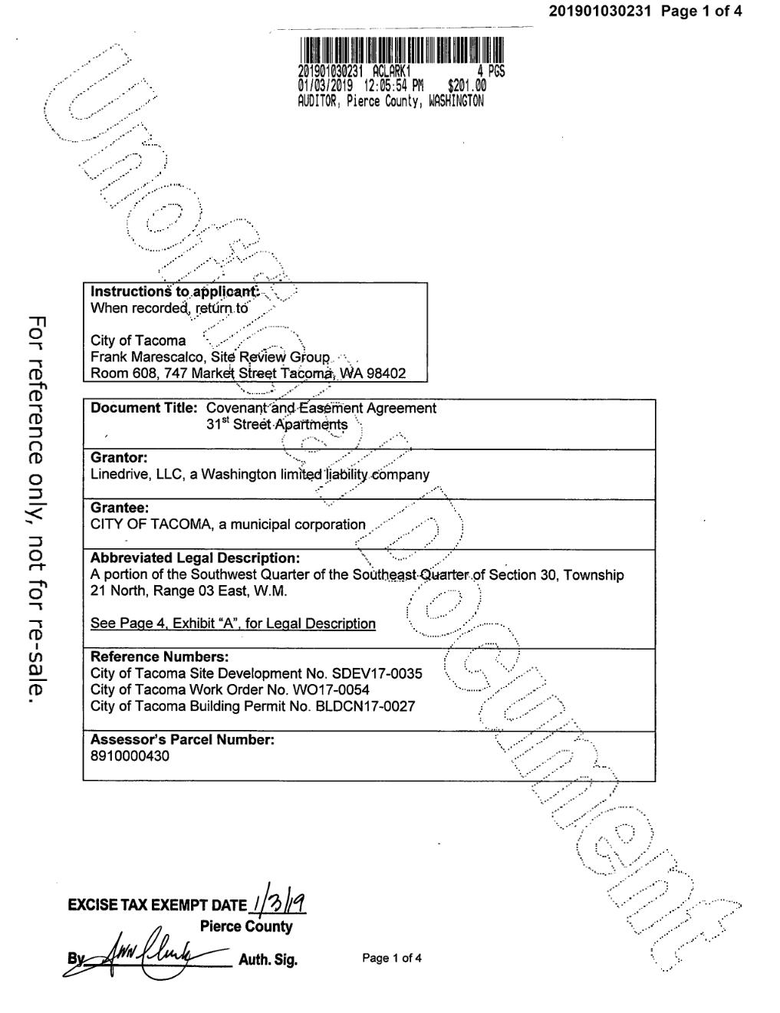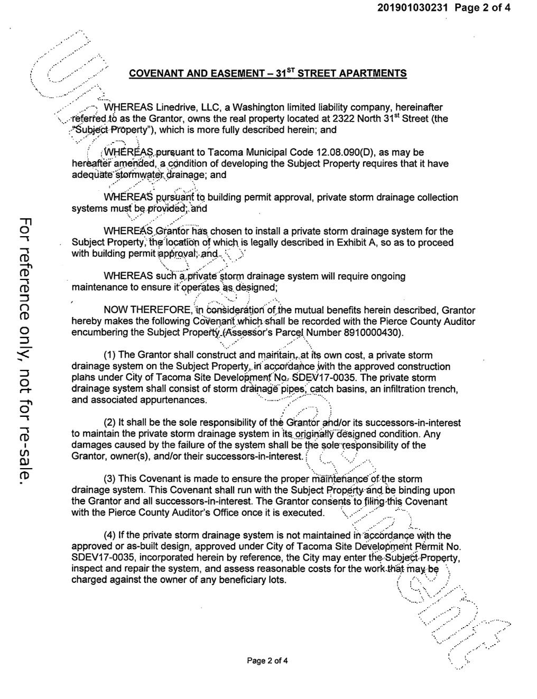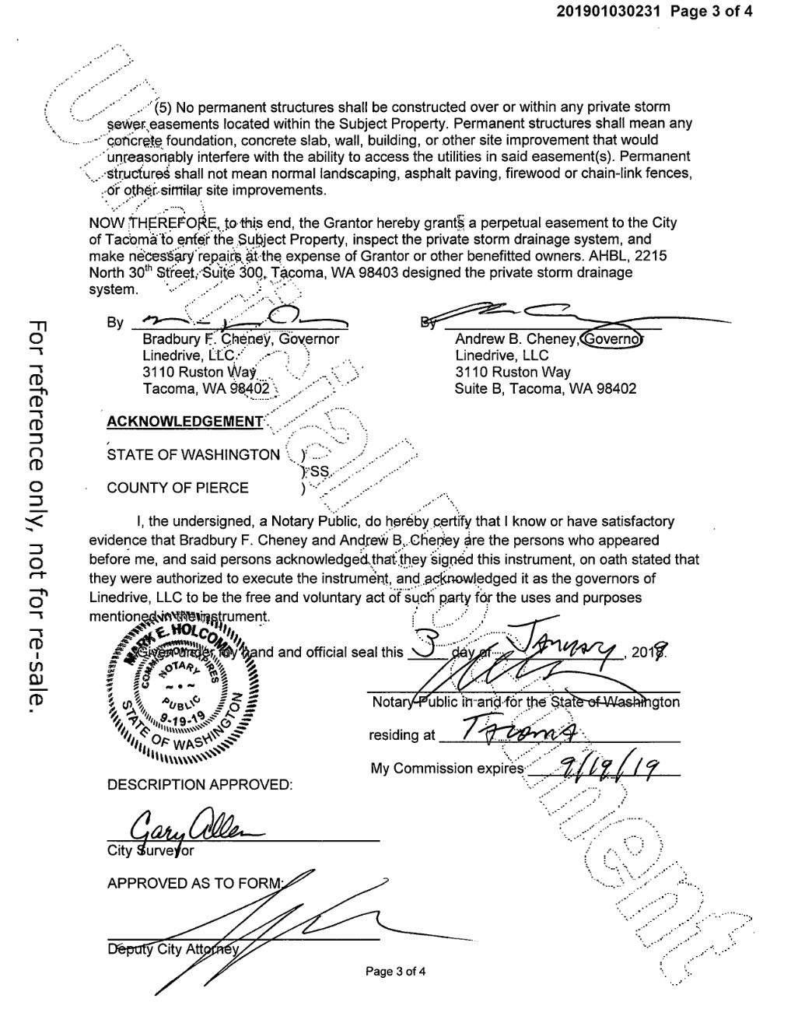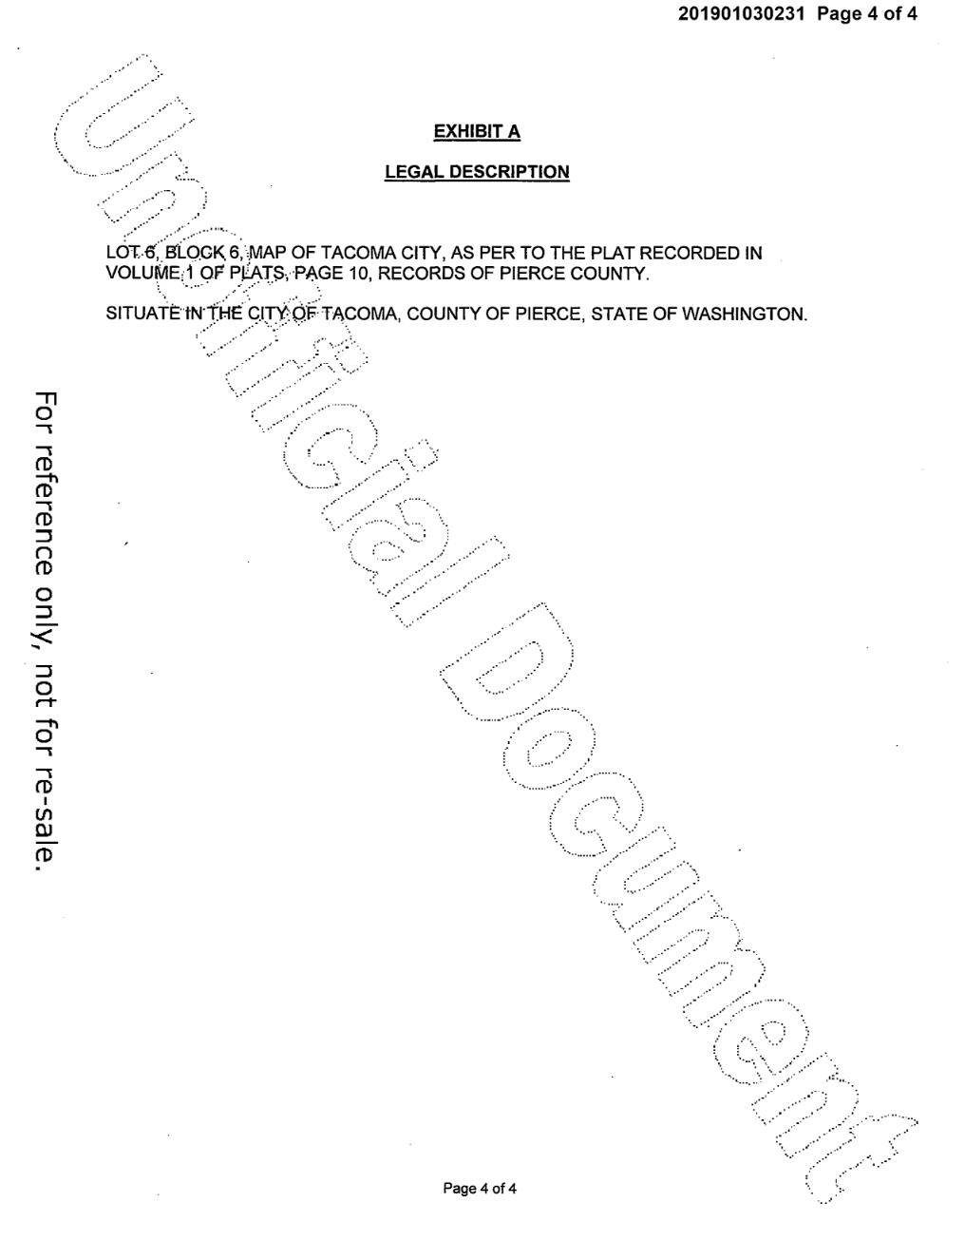
NOTE: THIS IS AN EXAMPLE C&E FROM A DIFFERENT PROJECT. THE C&E INCLUDED WOULD NEED TO BE FROM YOUR PROJECT.

